Frontend and Backend Architecture
From Web POC to Production Mobile App

Purpose
This section documents the recommended frontend and backend architecture for evolving the existing web-based proof of concept (index.html) into a production-grade, cross-platform mobile application deployable to the iOS App Store and Google Play Store.
It also explains which elements of the current implementation can be retained, which must be refactored, and which should be removed entirely.

Current State Overview (Web POC)
The current application is implemented as a single-page web app with the following characteristics:
- HTML for layout and structure
- CSS for styling, theming, and animations
- JavaScript for:
  - CSV parsing
  - reconciliation logic
  - KPI calculations
  - DOM rendering
  - user interaction handling
  - lightweight animations
This implementation has been highly effective for validating:
- the reconciliation logic
- the user experience
- the financial model
However, it tightly couples presentation, logic, and data handling, which limits scalability and App Store compatibility.

Target Architecture Overview - Production
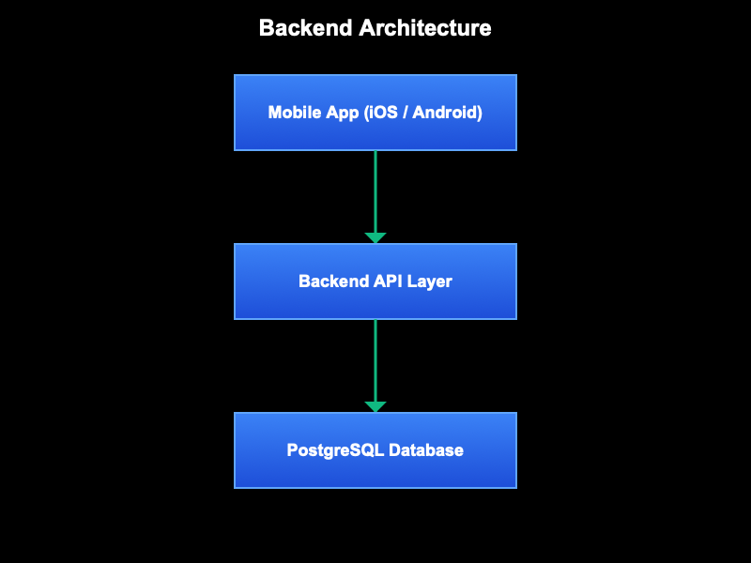
The production system adopts a clean separation of concerns:

Key principles:
- Mobile apps never access the database directly
- All financial logic is validated server-side
- The frontend focuses on experience, not data authority

Frontend Architecture

Target Frontend Stack
The recommended frontend stack is:
- React Native + Expo
- TypeScript
- Native file picker (CSV/PDF upload)
- Native animations and haptics
This provides:
- a single codebase for iOS and Android
- App Store compliance
- a native-quality experience
- direct reuse of JavaScript business logic

What Can Be Kept from the Current Web App
The following parts of the current index.html POC should be retained and reused, with minimal changes:

a) Core Business Logic (KEEP)
- Reconciliation calculations
- Outstanding vs repaid logic
- Refund pairing logic
- Monthly aggregation logic
- KPI derivations
These functions should be extracted into pure JavaScript / TypeScript utility modules that:
- do not reference the DOM
- accept inputs and return outputs
- can be shared between frontend and backend if needed
Example target structure:
/core
reconciliation.ts
refunds.ts
metrics.ts

b) Interaction Concepts (KEEP, IMPLEMENT NATIVELY)
The following UX patterns should be preserved:
- tap-to-select and expand elements
- animated number transitions
- swipe-based month navigation
- visual dimming of non-selected elements
These concepts translate cleanly to native interactions.

c) Visual Design Language (KEEP)
The existing:
- colour palette
- card hierarchy
- spacing rhythm
- typography scale
- dark theme
should be preserved and implemented as:
- theme tokens
- reusable components
- Tailwind-style utilities (e.g. NativeWind)

What Must Change in the Frontend

a) HTML & DOM Rendering (REMOVE)
All direct DOM usage must be removed, including:
- document.getElementById
- querySelector
- innerHTML
- inline HTML string templating
React Native replaces this with:
- declarative rendering
- state-driven UI
- reusable components

b) CSS Animations (REPLACE)
CSS-based transitions must be replaced with:
- React Native Animated or Reanimated
- Native gesture handlers
- Haptic feedback for key actions
This will improve perceived quality beyond the web experience.

c) Client-side CSV Fetching (REMOVE)
Static CSV fetching (fetch("activity.csv")) must be removed.
In production:
- the app only uploads files
- all parsing and persistence occur on the backend
- the app reads data exclusively via APIs

Backend Architecture

Backend Responsibilities
The backend is responsible for:
- file storage (CSV / PDF)
- statement ingestion
- parsing and normalisation
- transaction and payment persistence
- enforcing attribution and allocation rules
- exposing secure APIs to the mobile app

Recommended Backend Stack (MVP)
- Supabase
  - PostgreSQL (system of record)
  - Object storage (raw files)
  - Auth (users & sessions)
  - Edge Functions (ingestion & validation)
This stack enables rapid development without sacrificing correctness.

Backend Data Flow
- Mobile app uploads CSV
- Backend stores raw file immutably
- Statement snapshot is created
- Transactions and payments are inserted (no interpretation)
- User actions trigger:
  - payment attribution updates
  - payment allocation records
- KPIs are derived dynamically via database views

What Logic Moves to the Backend
The following logic should move from frontend to backend:
- CSV parsing and validation
- Duplicate detection
- Statement creation
- Payment persistence
- Allocation constraint enforcement
- KPI calculations (as views)
This ensures:
- consistency across devices
- data integrity
- auditability

What Remains Frontend-Only
The frontend retains responsibility for:
- file selection UX
- upload initiation
- displaying parsed results
- user confirmation flows
- animations and haptics
- visual explanation of balances
The frontend never becomes the source of truth.

Best Design Option for This App

Design Choice:
- React Native + Expo frontend
- Supabase backend
- PostgreSQL database
This combination provides:
- fastest route from POC to App Store
- maximum reuse of existing JavaScript logic
- native-quality UX
- strong support for AI-assisted development
- a clean future path for Python-based ML services

Summary
The current web POC is a strong foundation. Most of the intellectual value (reconciliation logic, UX concepts, and design language) should be preserved.
The transition to a production mobile app primarily involves:
- separating logic from presentation
- moving data authority to the backend
- replacing browser-specific constructs with native equivalents
This approach minimises risk, maximises development speed, and results in a scalable, trustworthy application suitable for real users and App Store distribution.

